**DAILY ONLINE ACTIVITIES SUMMARY**

|  |  |  |  |  |  |
| --- | --- | --- | --- | --- | --- |
| **Date:** | | **13/06/2020** | **Name:** | **JASLINE SHARON TAURO** | |
| **Sem & Sec** | | **4th sem, A Section** | **USN:** | **4AL18CS029** | |
| **Online Test Summary** | | | | | |
| **Subject** | **DATA COMMUNICATION** | | | | |
| **Max. Marks** | **30** | | **Score** | **13** | |
| **Certification Course Summary** | | | | | |
| **Course** | | 1. Blockchain [Ethereum]workshop 2. Application Developer | | | |
| **Certificate Provider** | | 1. **Emurgo Academy** 2. **AWS Educate** | **Duration** | | **1)1.30 hrs.**  **2)2 hrs.** |
| **Coding Challenges** | | | | | |
| **Problem Statement:**   1. Write a C Program to calculate Electricity Bill. 2. Write a program to find the first non-repeated character of a given String. | | | | | |
| **Status: EXECUTED** | | | | | |
| **Uploaded the report in GitHub** | | | **YES** | | |
| **If yes Repository name** | | | <https://github.com/jaslinesharontauro/C_Prgms>  <https://github.com/jaslinesharontauro/JAVA_Prgms> | | |
| **Uploaded the report in slack** | | | **YES** | | |

Online Test Details: (Attach the snapshot and briefly write the report for the same)

Certification Course Details: (Attach the snapshot and briefly write the report for the same)

Coding Challenges Details: (Attach the snapshot and briefly write the report for the same)

1.ONLINE TEST DETAILS:

Today we had assessment in the subject DATA COMMUNICATION. The test was based on first and second module of this subject. Test was comprised of total 30 questions of one mark each, out of which I scored 13.

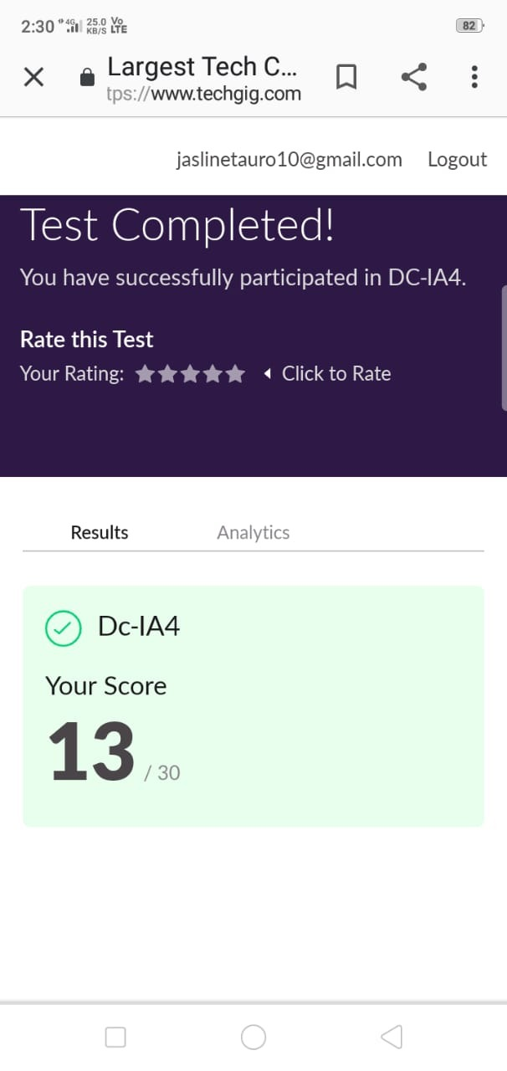

2.CERTIFICATION COURSE DETAILS:

Today I have attended a webinar on “UNCHAIN ETHEREUM & ITS POTENTIAL” by Emurgo Academy. This webinar was very interesting. I learnt about the potential of Ethereum in various domains such as Business, Gaming, Animation and also some real-world domains.

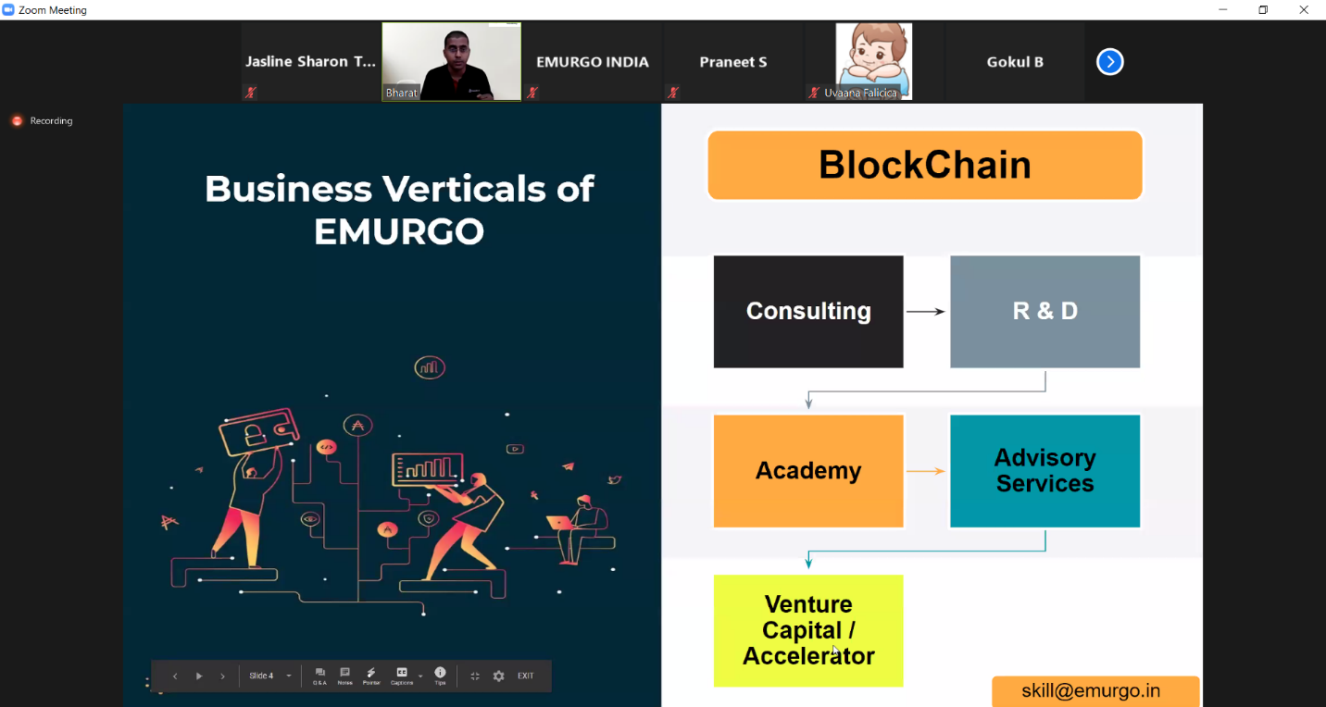

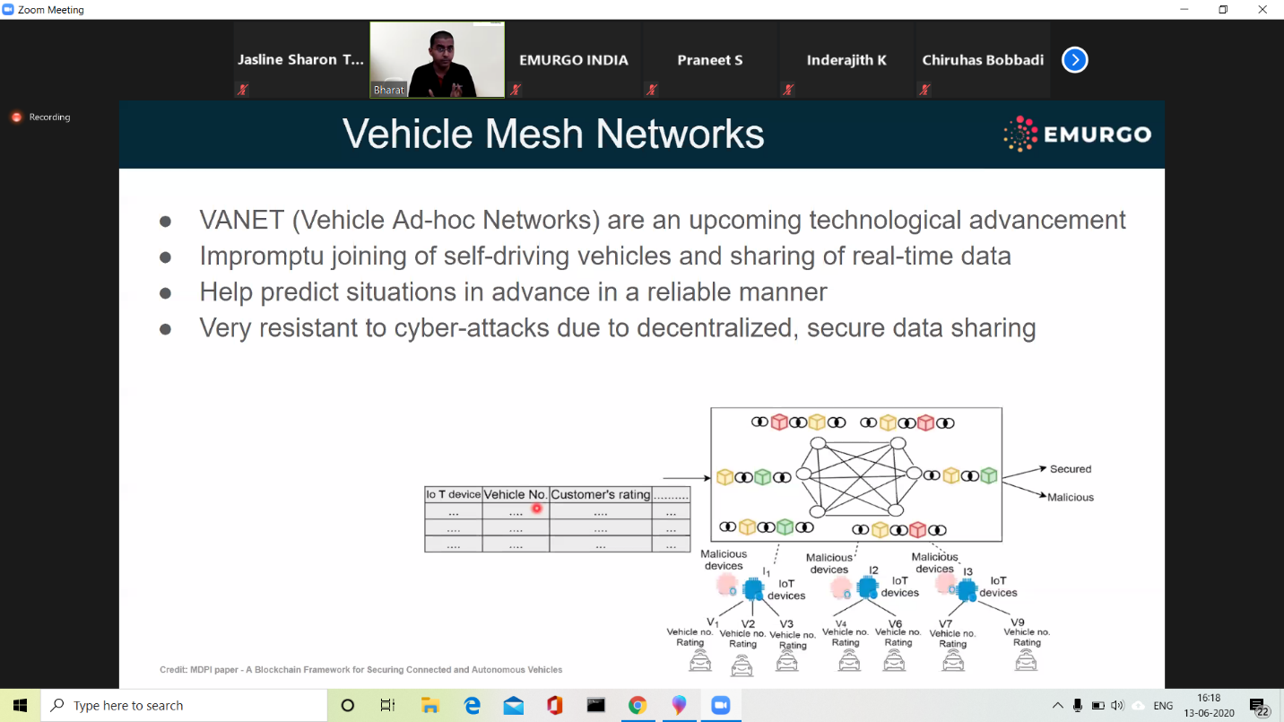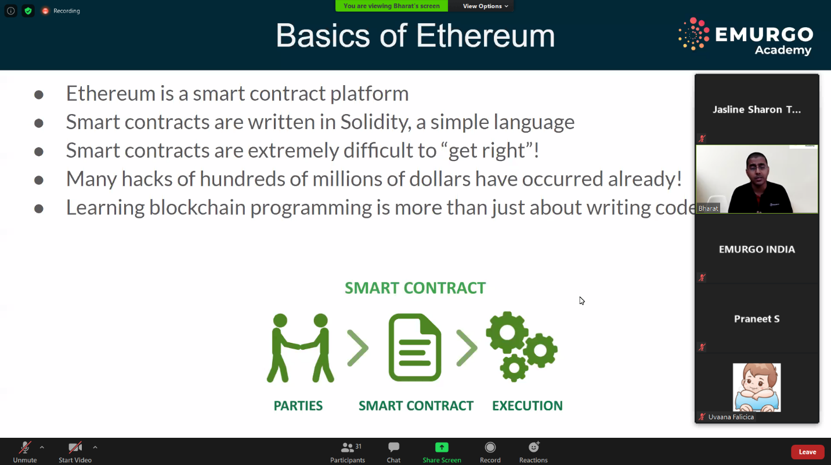

I have started a new course “Application Developer” by AWS Educate. In this course today I learnt about Introduction of software development and its tools. I have successfully completed the first module of this course.

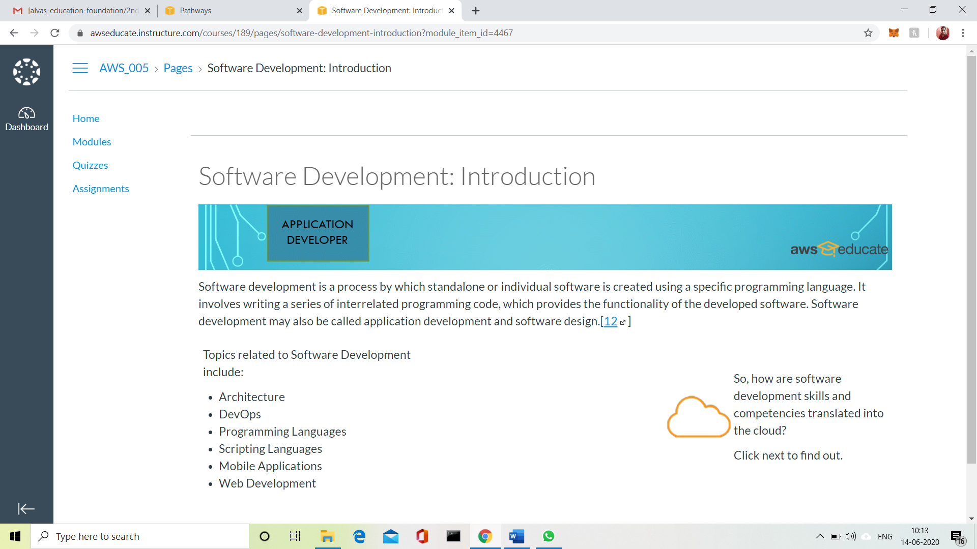

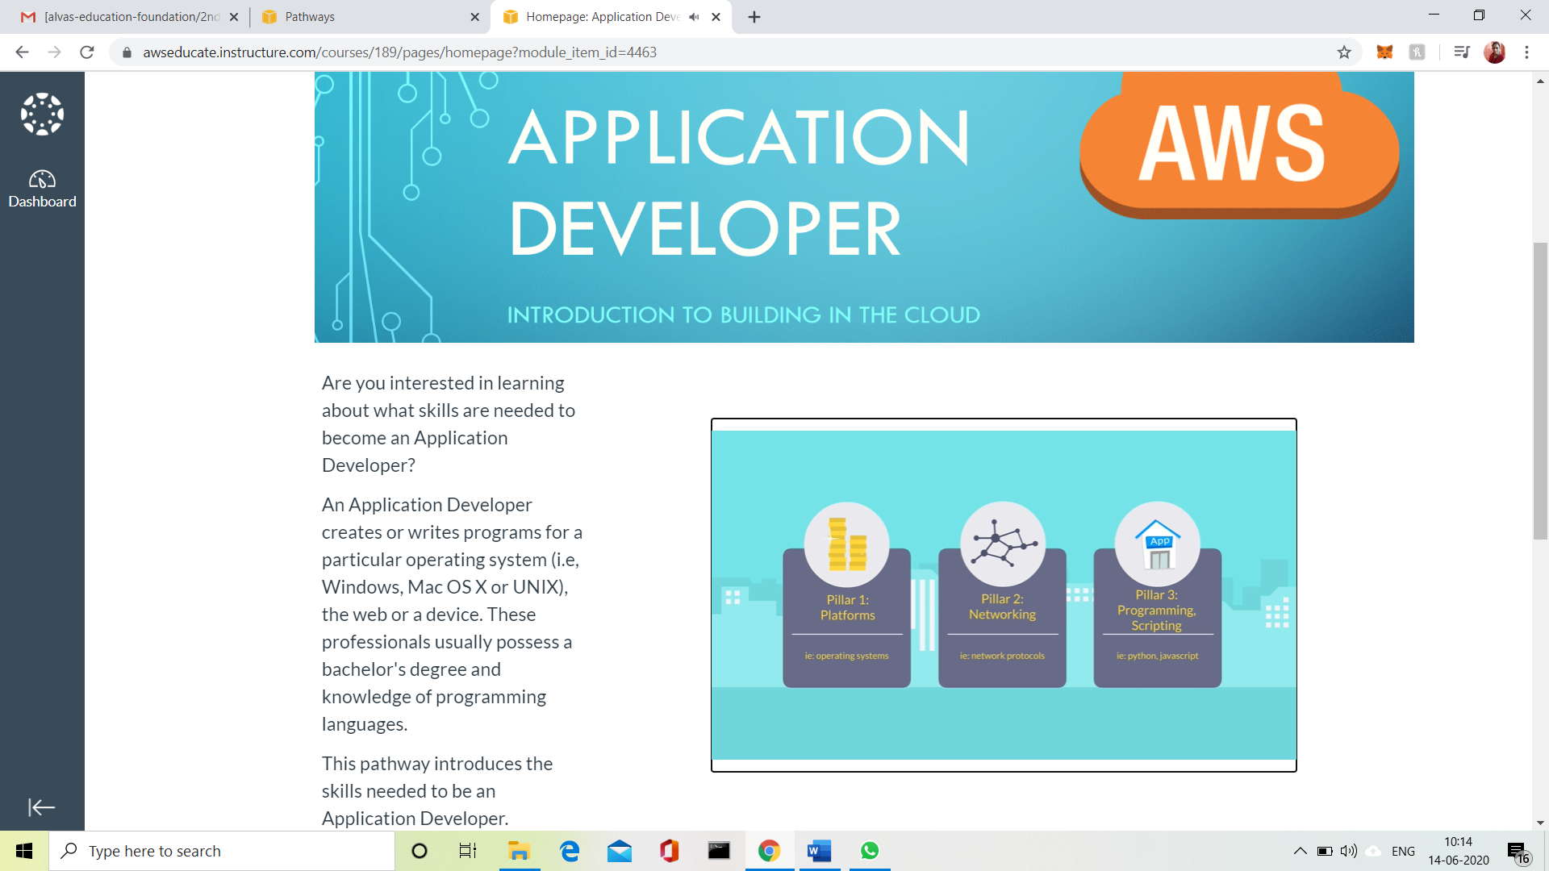

3.CODING CHALLENGES:

Problem Statement 1:

Write a C Program to calculate Electricity Bill.

Given an integer U denoting the amount of KWh units of electricity consumed, the task is to calculate the electricity bill with the help of the below charges:  
• 1 to 100 units – Rs 10/- Per Unit  
• 100 to 200 units – Rs. 15/- Per Unit  
• 200 to 300 units – Rs. 20/- Per Unit  
• above 300 units – Rs. 25/- Per Unit

Examples:

Input: U = 250

Output: 3500

Explanation:

Charge for the first 100 units – 10*100 = 1000  
Charge for the 100 to 200 units – 15*100 = 1500  
Charge for the 200 to 250 units – 20*50 = 1000  
Total Electricity Bill = 1000 + 1500 + 1000 = 3500

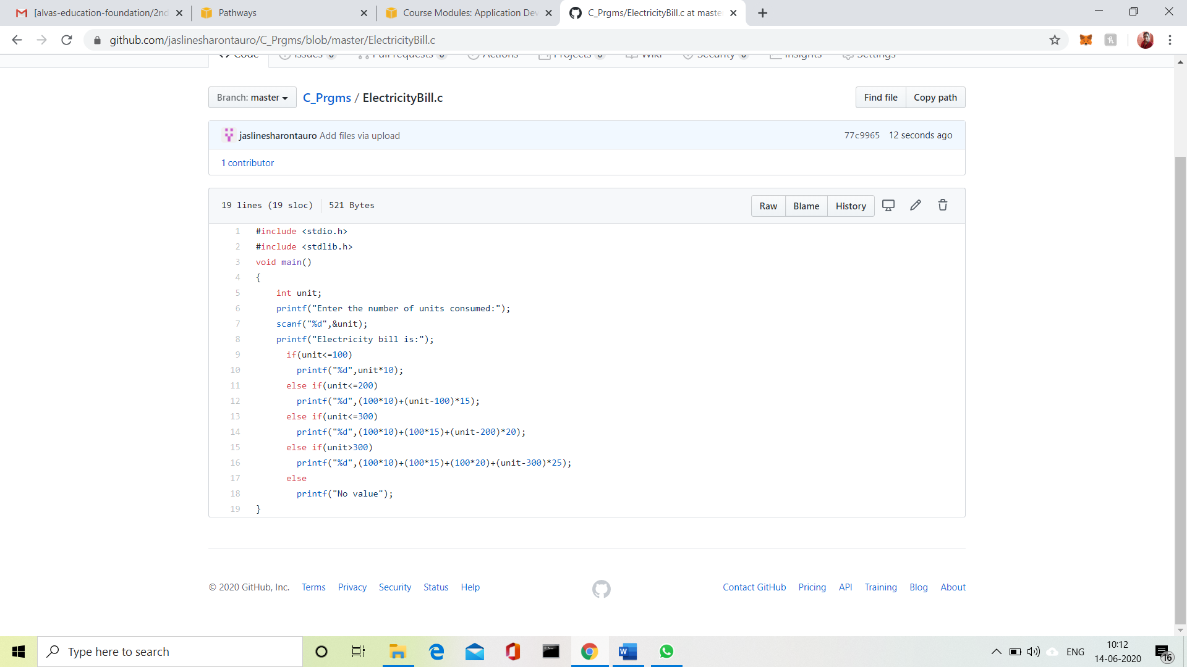

Solution uploaded in GitHub.

Problem Statement 2:

Write a program to find the first non-repeated character of a given String.

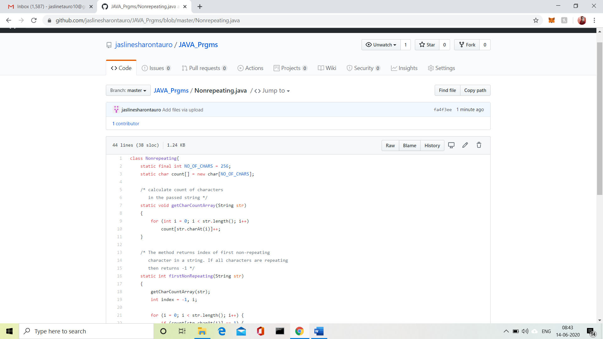

Solution uploaded in GitHub.